**Week 2 Exercise: Logic and Python - Introduction to Basic Data Types, Functions and Github**

**Name:**

**Instructions**

This assignment has two sections. The first section includes 5 short answer questions. The second part of the assignment is connecting through GitHub.

If you have any questions on how to start or if you get stuck, refer to the discussion board and ask your questions there. You are allowed to use your notes, lectures and the internet. Students can work together on the question portion and discuss the coding exercise. For the coding exercise, you are allowed to talk to other classmates but you cannot have the same code.

Once complete, please save your assignment as a PDF and submit it both to the online course [and tag](https://docs.github.com/en/free-pro-team@latest/desktop/contributing-and-collaborating-using-github-desktop/managing-tags) your instructor on Github.

**Short Answer (1 point each)**

1. In your own words, explain what you believe Git is: Git is a vehicle which enables users or several users in a group to label what/why modifications are being made and to save the version almost in a separate ordered folder both on a share drive (GitHub) and on the computer so that you can always go back to prior versions and look at the revisions.

2. What are the basic usages of Git?

The basic uses of git are to have one or more users working on a file and to be able to save that file independently and always be able to track who viewed the file and what changes were made.

With Git, you can:

Initiate a file (git init)

Add a file name (git add)

Request status (git status) of the file you are viewing

Review a log (git log) of who and what/why changes were made

Enter notation of what/why change and save (git commit)

Checkout files (git checkout)

(And my favorite one) Get help (git status –help)

Merging changes into master

3. What are the disadvantages of GitHub?

I found one of the disadvantages of GITHub was the specific language needed for the commands. Also, I understand that it costs money to have a private share space.

4. What security features does GitHub offer?

Two-factor Authentication (2FA, SMS, TOTP)

Universal Second Factor (U2F)

Delegated Account Recovery

Git over SSH and HTTP

GPG commit-signing verification.

Email privacy controls

Security audit log

Retrieved from : https://github.com/security

**Coding Exercise (6 points)**

Please set up with Github. Github will be our way to send files during the course and for your instructor to give you specific feedback on assignments. Please note, you are still required to submit your assignments in the online course in addition to Github.

This is a quick overview of what you will be doing:

1. Generate SSH Key

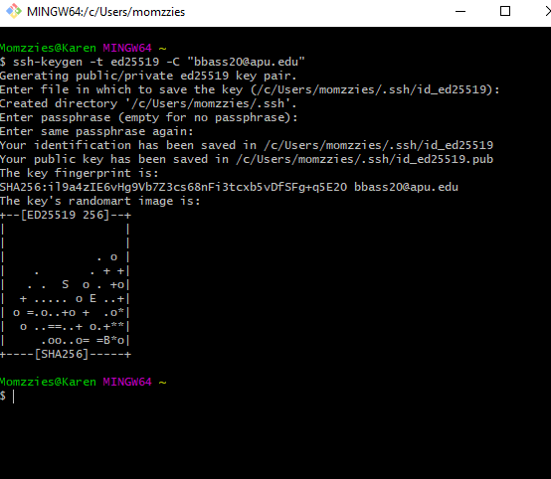

1. Add SSH Key to GitHub.com

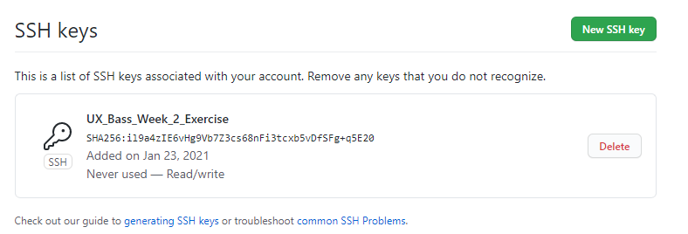

## Configure some git settings

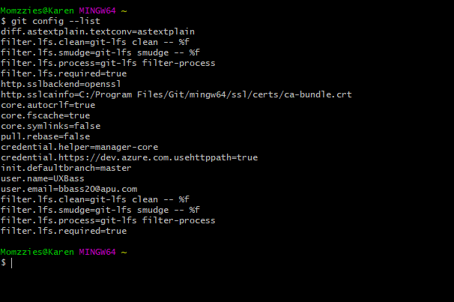

1. Fork the class repository on GitHub

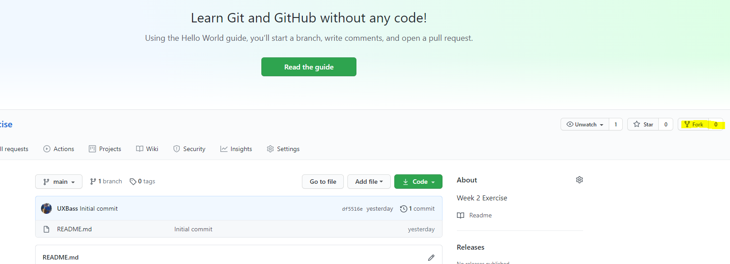

1. Connect to the class repository

**Instructions:**

Please go to this link and follow the instructions:

[ttps://product.hubspot.com/blog/git-and-github-tutorial-for-beginners](https://product.hubspot.com/blog/git-and-github-tutorial-for-beginners)

You can also take a look at the PDF version of the instructions:

[PDF version](https://drive.google.com/file/d/1aP1oZC8pUPa03FjmKk7_c1JaMBhb7U1Z/view?usp=sharing)

Once you have completed this portion of the assignment, **your instructor will send you a message through GitHub to confirm you are connected.**